TE ROPU WAHINE MAORI TOKO I TE ORA
WAIARIKI ROHE – ROTORUA 2023
Arts & Crafts – Resources for Tamariki Criteria

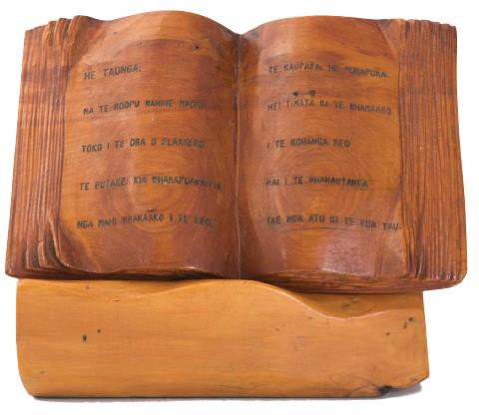 | Ika Roa Trophy (0-2 years) - Te Reo Resource Book for Tamariki (0-2 years)  - The pukapuka is written in Te Reo Maori for 0-2 year olds.  - The pukapuka has the title, author and illustrator details displayed on the front cover.  - Must be 8 pages excluding the Title Page.  - The Kaupapa must relate to the National Conference –  “Tauwharautia te haa o Nga Wahine Maori Toko I te Ora”
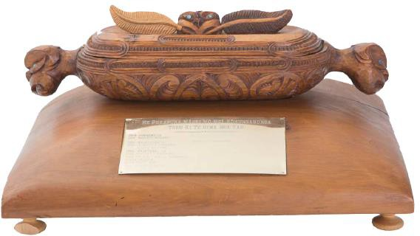 | Ika Roa Trophy (3-5 years) - Te Reo Resource Book for Tamariki (3-5 years)  - The pukapuka is written in Te Reo Maori for 3-5 year olds.  - The pukapuka has the title, author and illustrator details displayed on the front cover.  - Must be 10 pages excluding the Title Page.  - The Kaupapa must relate to the National Conference –  “Tauwharautia te haa o Nga Wahine Maori Toko I te Ora”
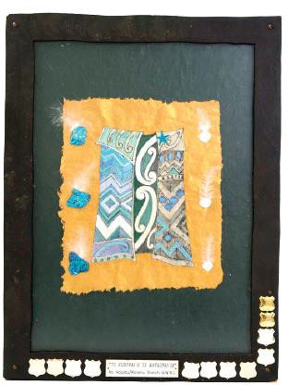 | Te Kahu o te Matauranga (6-9 years) - Te Reo Resource Book for Tamariki (6-9 years)  - The pukapuka is written in Te Reo Maori for 6-9 year olds.  - The pukapuka has the title, author and illustrator details displayed on the front cover.  - Must be 8 pages excluding the Title Page.  - The Kaupapa must relate to the National Conference –  “Tauwharautia te haa o Nga Wahine Maori Toko I te Ora”

