TE ROPU WAHINE MAORI TOKO I TE ORA
WAIARIKI ROHE – ROTORUA 2023
Arts & Crafts - Branch Report Criteria

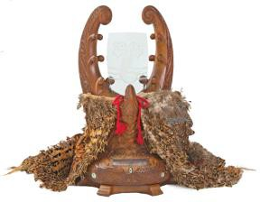 | Te Puea Trophy (for Best Annual Report)  - The Annual Report belongs to a financial Senior Branch.  - Activities connect to the League Objects.  - Accomplishments of the Branch are outlined.  - Pictures, Profiles, testimonials and anecdotes about the impact of your branch work are provided.
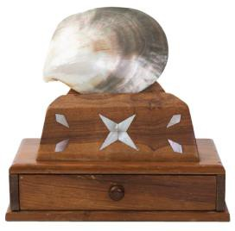 | Penrhyn Trophy ( Runner Up – for Annual Report)  - The Annual Report belongs to a financial Senior Branch.  - Activities connect to the League Objects.  - Accomplishments of the Branch are outlined.  - Pictures, Profiles, testimonials and anecdotes about the impact of your branch work are provided.
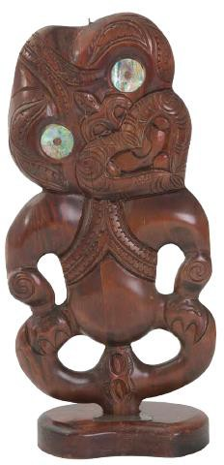 | Gwyn Ryan Trophy (for Best Annual Report)  - The Annual Report belongs to a financial Junior Branch.  - Activities connect to the League Objects.  - Accomplishments of the Branch are outlined.  - Pictures, Profiles, testimonials and anecdotes about the impact of your branch work are provided.

