
Te Roopu Wahine Maori Toko i te Ora
National Conference 2026 – Tamaki Makaurau
Due Drop Event Centre, 770 Great South Road, Wiri, Manukau, 2104, AUCKLAND
Arts & Crafts Competitions

Rohe:
Peka:
Contact person:
Phone: |  |  | Email
Competition Entry: | Tukutuku  ☐ Miriona-Utu Budge ☐ Te Arahina | Kete  ☐ Te Ara Wahine  ☐ Te Kete Aroha  ☐ Ngati Kahu o Kenana |  | Contemporary Art  ☐ Hinemoana Paniora (15-18yrs)  ☐ Te Ngira o Pakowhai (Int)  ☐ Te Ngira o Pakowhai (Rangatahi) | Taniko & Whakairo  ☐ Joan Walmsley (Taniko)  ☐ Simon Snowden Memorial (Whakairo)

Please email your registration to competitions@mwwl.org.nz Registrations close Friday 28 August 2026.
- Ensure all tick boxes for branch entry is ticked above, or your item/s will not be accepted.
- It is the branch’s responsibility to bring competition items to National Conference.
- Competition items can be received on Wednesday 7 October at National Conference after the powhiri.
- Competition items must be picked up by 4pm Saturday 10 October.

Kete Competitions:

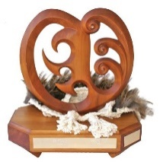 | 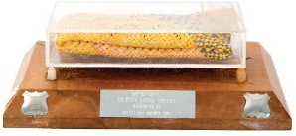 | 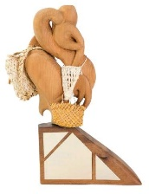
Te Ara Wahine Trophy  for Kete Harakeke - Beginners | Te Kete Aroha Trophy  for Kete Whakairo in Harakeke – Pattern Flax | Ngati Kahu o Kenana  for Kete Whakairo in Harakeke – Coloured
Criteria | Criteria | Criteria
- Must be raw kete harakeke  - Must be weaved by a beginner weaver  - Must be produced with a plaited base  - The Kete Harakeke measures 29.7cm by 21cm = A4 | - The Kete Whakairo is harakeke, to be dyed in one colour only.  - Raranga Whakairo technique with a whakairo pattern.  - Must include muka handles.  - The Kete Whakairo measures 29.7cm by 21cm = A4 | - The piece is a Kete Whakairo in harakeke  - The Kete Whakairo is coloured.  - Use of natural resources and/or a combination of all.  - The Kete Whakairo measures 29.7cm by 21cm = A4

Tukutuku Competitions:
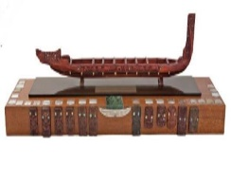 | 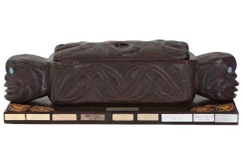
Miriona-Utu Budge Trophy  for the best tukutuku entry / traditional material (Unlined) | Te Arahina Trophy  for the best tukutuku entry / contemporary style (Unlined)
Criteria | Criteria
- To make a Tukutuku panel measuring 29.7cm by 28cm  - 100% use of customary materials ie., natural resource (mahinga kai)  - Technique will be evaluated.  - The kaupapa of the Tukutuku panel is  “Whakamaua te Aho Matua” – weaving the Past, Present and Future | - To make a Tukutuku panel measuring 29.7cm by 28cm  - 100% use of contemporary materials.  - Technique will be evaluated.  - The kaupapa of the Tukutuku panel is  “Whakamaua te Aho Matua” – weaving the Past, Present and Future

Contemporary Māori Art Competitions:
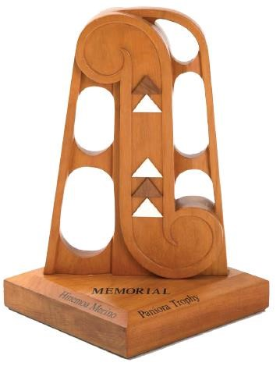 | 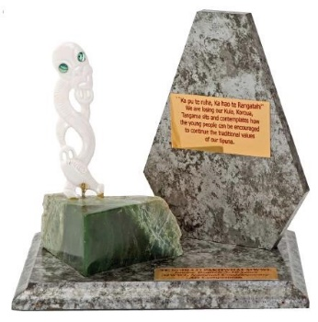 | 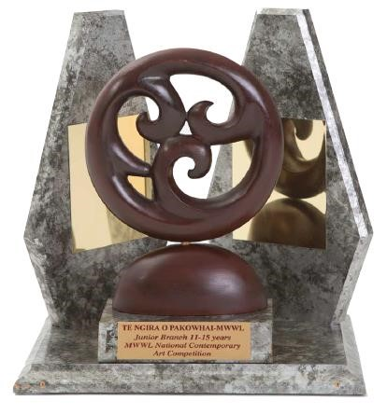
Hinemoana Paniora Trophy  for Rangatahi Contemporary Māori Art | Te Ngira o Pakowhai Intermediate Trophy  for Intermediate Contemporary Māori Art | Te Ngira o Pakowhai Intermediate Trophy  for Rangatahi Contemporary Māori Art
Criteria | Criteria | Criteria
- The artist is aged between 15 and 18 years. Photograph of artist must accompany item.  - The artwork is 2 or 3 -dimensional  - The kaupapa of the Contemporary Art is “Whakamaua te Aho Matua” – weaving the Past, Present and Future  - No Size Limit and Open Criteria | - The artist is aged between 10 and 12 years.  - Photograph of artist must accompany item.  - May use any type of resource  - The kaupapa of the Contemporary Art is  “Whakamaua te Aho Matua” – weaving the Past, Present and Future  - No size limit and open criteria. | - The artist is aged between 13 and 15 years.  - Photograph of artist must accompany item.  - The Contemporary art is 2 or 3 -dimensional  - The kaupapa of the Contemporary  “Whakamaua te Aho Matua” – weaving the Past, Present and Future  - No size limit and open criteria.

Taniko & Whakairo Competitions:
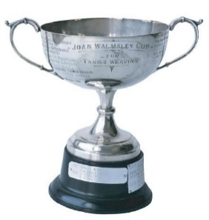 | 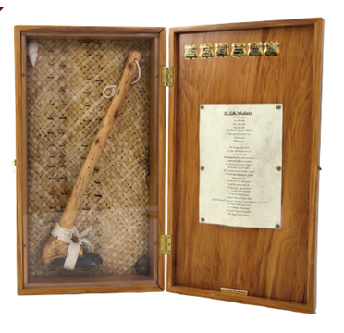
Joan Walmsley Cup  for the best taniko entry | Simon Snowden Memorial Trophy  for the best whakairo entry
Criteria | Criteria
- To weave a Taniko piece unlined.  - Use traditional Taniko techniques.  - The Taniko will incorporate the use of at least 3 colours.  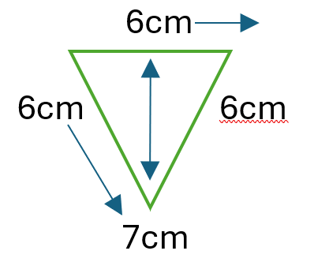  - Please provide a niho taniwha necklace piece with the cord  - The kaupapa of the Contemporary Art is  “Whakamaua te Aho Matua” – weaving the Past, Present and Future | - Produce a Toi whakairo art piece (carving)  - The Toi Whakairo is created from wood, stone or bone.  - No size limit and open criteria must be free standing.  - The kaupapa of the Contemporary Art is  “Whakamaua te Aho Matua” – weaving the Past, Present and Future

