TE ROPU WAHINE MAORI TOKO I TE ORA
WAIARIKI ROHE – ROTORUA 2023
Arts & Crafts- Craft Trophy Registrations

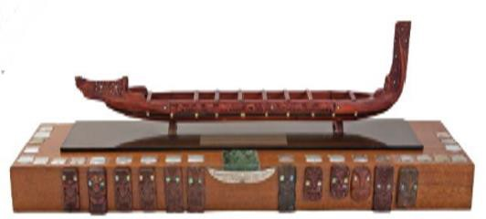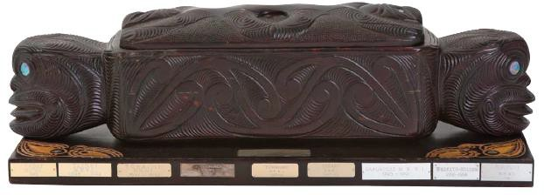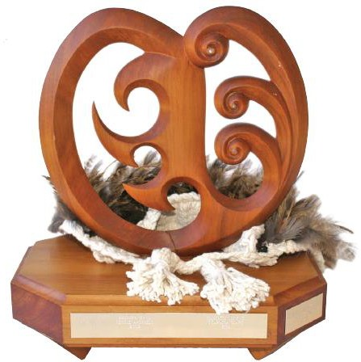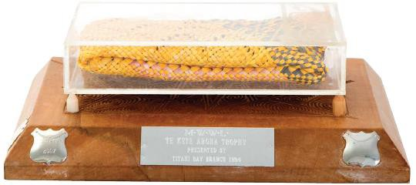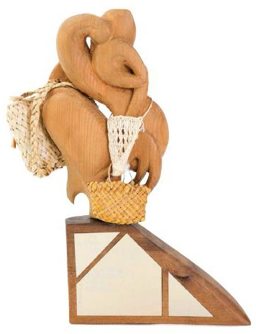
Miriona Utu Budge Te Arahina Te Ara Wahine Te Kete Aroha Ngāti Kahu o Kenana

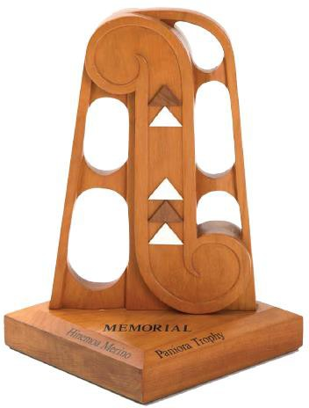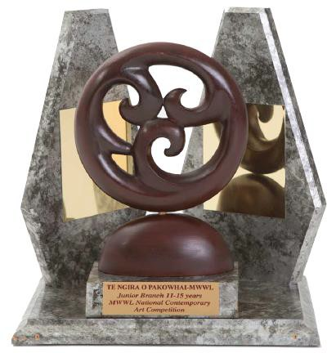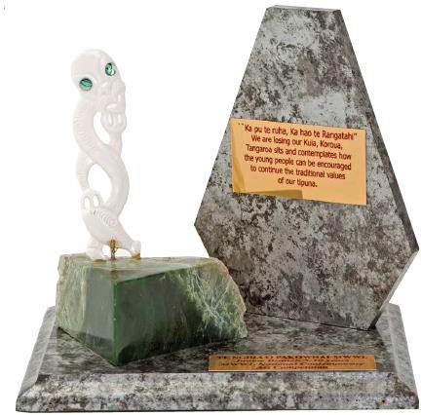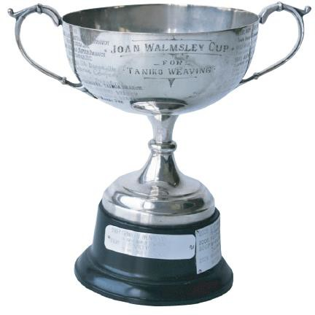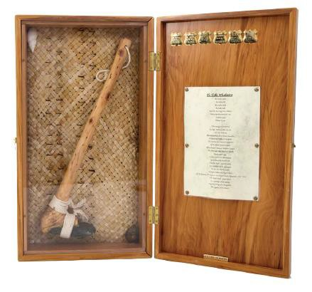
Hinemoana Paniora Te Ngira o Pakowhai Te Ngira o Pakowhai Joan Walmsley Cup Simon Snowden Memorial
Intermediate Rangatahi

Please  what entries you will be bringing to Nationals:
 | Miriona-Utu Budge Trophy  For the best Tukutuku entry (Traditional Material – unlined) |  | Hinemoana Paniora  Rangatahi Contemporary Māori Art – (15-18 years)
 | Te Arahina  For the best Tukutuku entry in a contemporary style - unlined |  | Te Ngira o Pakowhai – Intermediate  Contemporary Art
 | Te Ara Wahine  For Kete Harakeke - Beginners |  | Te Ngira o Pakowhai - Rangatahi  Contemporary Art
 | Te Kete Aroha  Kete Whakairo in harakeke – Pattern Flax only 27cm x 20 cm |  | Joan Walmsley Cup  For best Taniko entry
 | Ngāti Kahu o Kenana  Kete Whakairo in harakeke – Coloured. Kiekie, pingao, kuta or with adornments e.g. feathers 27cm x 20 cm |  | Simon Snowden Memorial  For Whakairo

- All entry forms must be received by or before Friday, 15th September 2023, 5.00 p.m.
- If the item is not ticked as per above, your item will not be accepted.
- It is the branches responsibility to bring all competition items to the National Hui.
- All competition items will be registered on Tuesday, 3rd October after the Powhiri – time to be advised.
- Competition items must be picked up – Friday, 6th October during morning tea.

Please note that if your item does NOT fit the criteria. It will not be judged.
Rohe
Peka
Contact Person
Cellphone: |  | Email:
Signed: |  | Date:

Please email form to: competitions@mwwl.org.nz

