
National Competition for
Arts & Crafts 2026 Pānui

Te Ropu Wahine Maori Toko I te Ora
Maori Womens Welfare League Inc
____________________________________________________________________
Tēnā koutou ngā maungā whakahii, ngā mātā waka nō ngā hau e whā. Ngā mātou te honore hei karangahia kia koutou.
Anei he pānui e pa ana ki te Arts & Crafts Competition o Te Ropu Wahine Wahine Maori Toko i te Ora 2026.
Hereia mai ō koutou taonga i muri i te mutungā o te pōhiri i Wenerei 7 Whiringa-a-nuku. Kā timata te whakataetae i Taite 8 Whiringa-a-nuku 2026 kei Due Drop Event Centre, 770 Great South Road, Wiri, Manukau, 2104, AUCKLAND
Anei ngā whakamarama.
- ELIGIBILITY TO COMPETE
- All participating peka must be financial regionally and nationally for the 2025-2026 financial year.

- THEME FOR ALL CATEGORIES
- The theme of the 2026 National Conference is Whakamaua te aho matua. Weaving the past, present and future.

- GUIDELINES
- Please ensure the peka name is not displayed on the taonga
- Measurements of taonga, where required, must be adhered to in the relevant sections
- Submit branch financial overview for the 2025/2026 period for Annual Report Competition.
- Annual reports to be couriered to National Office, 24 Burnell Ave, Thorndon, Wellington, 6011 by Friday 11 September 2026.
- Any queries can be emailed to competitions@mwwl.org.nz

- SUBMITTING OF TAONGA
- All taonga can be submitted following pōhiri on Wednesday 7 October 2026, to the designated area
- Announcements will be made at the kai hakari regarding further details

Kete Competitions:

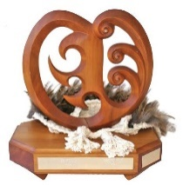 | 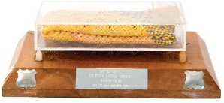 | 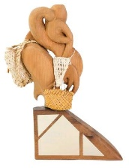
Te Ara Wahine Trophy  for Kete Harakeke - Beginners | Te Kete Aroha Trophy  for Kete Whakairo in Harakeke – Pattern Flax | Ngati Kahu o Kenana  for Kete Whakairo in Harakeke – Coloured
Criteria | Criteria | Criteria
- Must be raw kete harakeke  - Must be weaved by a beginner weaver  - Must be produced with a plaited base  - The Kete Harakeke measures 29.7cm by 21cm = A4 | - The Kete Whakairo is harakeke, to be dyed in one colour only.  - Raranga Whakairo technique with a whakairo pattern.  - Must include muka handles.  - The Kete Whakairo measures 29.7cm by 21cm = A4 | - The piece is a Kete Whakairo in harakeke  - The Kete Whakairo is coloured.  - Use of natural resources and/or a combination of all.  - The Kete Whakairo measures 29.7cm by 21cm = A4

Tukutuku Competitions:
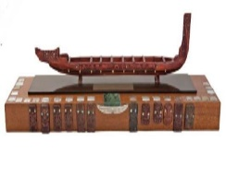 | 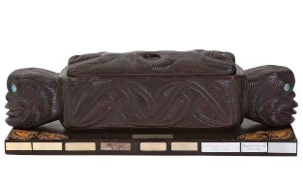
Miriona-Utu Budge Trophy  for the best tukutuku entry / traditional material (Unlined) | Te Arahina Trophy  for the best tukutuku entry / contemporary style (Unlined)
Criteria | Criteria
- To make a Tukutuku panel measuring 29.7cm by 28cm  - 100% use of customary materials ie., natural resource (mahinga kai)  - Technique will be evaluated.  - The kaupapa of the Tukutuku panel is  “Whakamaua te Aho Matua” – weaving the Past, Present and Future | - To make a Tukutuku panel measuring 29.7cm by 28cm  - 100% use of contemporary materials.  - Technique will be evaluated.  - The kaupapa of the Tukutuku panel is  “Whakamaua te Aho Matua” – weaving the Past, Present and Future

Contemporary Māori Art Competitions:
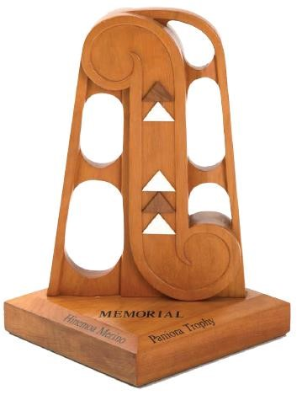 | 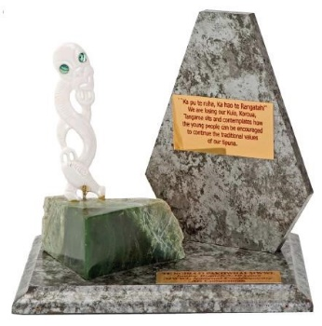 | 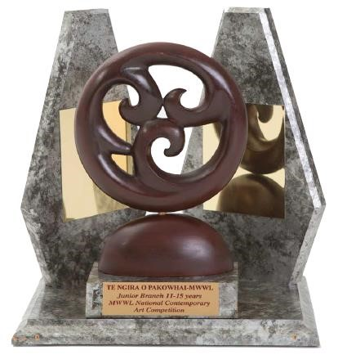
Hinemoana Paniora Trophy  for Rangatahi Contemporary Māori Art | Te Ngira o Pakowhai Intermediate Trophy  for Intermediate Contemporary Māori Art | Te Ngira o Pakowhai Junior Trophy  for Rangatahi Contemporary Māori Art
Criteria | Criteria | Criteria
- The artist is aged between 15 and 18 years. Photograph of artist must accompany item.  - The artwork is 2 or 3 -dimensional  - The kaupapa of the Contemporary Art is “Whakamaua te Aho Matua” – weaving the Past, Present and Future  - No Size Limit and Open Criteria | - The artist is aged between 5 to 10 years.  - Photograph of artist must accompany item.  - May use any type of resource  - The kaupapa of the Contemporary Art is  “Whakamaua te Aho Matua” – weaving the Past, Present and Future  - No size limit and open criteria. | - The artist is aged between 11 and 15 years.  - Photograph of artist must accompany item.  - The Contemporary art is 2 or 3 -dimensional  - The kaupapa of the Contemporary  “Whakamaua te Aho Matua” – weaving the Past, Present and Future  - No size limit and open criteria.

Taniko & Whakairo Competitions:
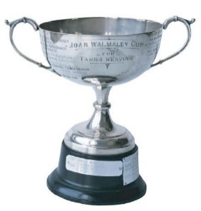 | 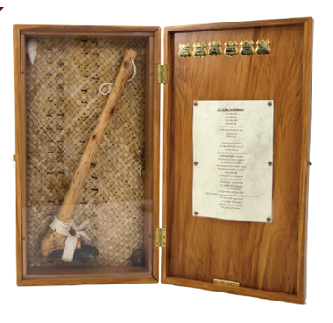
Joan Walmsley Cup  for the best taniko entry | Simon Snowden Memorial Trophy  for the best whakairo entry
Criteria | Criteria
- To weave a Taniko piece unlined.  - Use traditional Taniko techniques.  - The Taniko will incorporate the use of at least 3 colours.  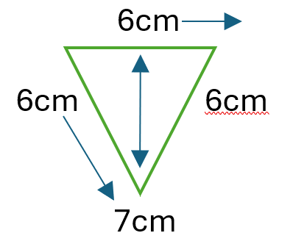  - Please provide a niho taniwha necklace piece with the cord  - The kaupapa of the Contemporary Art is  “Whakamaua te Aho Matua” – weaving the Past, Present and Future | - Produce a Toi whakairo art piece (carving)  - The Toi Whakairo is created from wood, stone or bone.  - No size limit and open criteria must be free standing.  - The kaupapa of the Contemporary Art is  “Whakamaua te Aho Matua” – weaving the Past, Present and Future

Pukapuka Competitions:
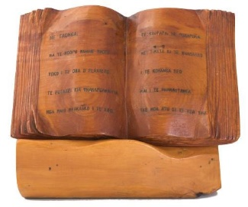 | 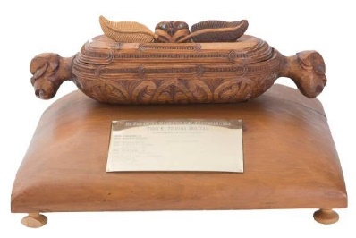 | 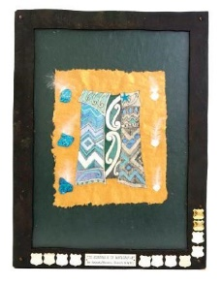
Ikaroa Trophy (0-2 yrs)  for the best Te Reo Resource Book for tamariki | Ikaroa Trophy (3-5 yrs)  for the best Te Reo Resource Book for tamariki | Te Kahu o te Matauranga (6-9 yrs)  for the best Te Reo Resource Book for tamariki
Criteria | Criteria | Criteria
- The pukapuka is written in Te Reo Maori for 0-2 year olds.  - The pukapuka has the title, author and illustrator details displayed on the front cover.  - The kaupapa must relate to  “Whakamaua te Aho Matua” weaving the Past, Present and Future.  - Must be 8 pages excluding the Title Page. | - The pukapuka is written in Te Reo Maori for 3-5 year olds.  - The pukapuka has the title, author and illustrator details displayed on the front cover.  - The kaupapa must relate to  “Whakamaua te Aho Matua” weaving the Past, Present and Future.  - Must be 10 pages excluding the Title Page. | - The pukapuka is written in Te Reo Maori.  - The pukapuka has the title, author and illustrator details displayed on the front cover.  - The kaupapa must relate to  “Whakamaua te Aho Matua” weaving the Past, Present and Future.  - Must be 8 pages excluding the Title Page.

Annual Reports Competitions:
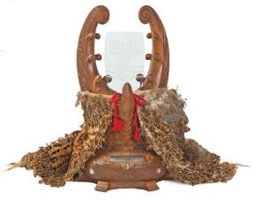 | 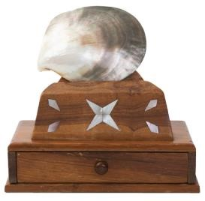 | 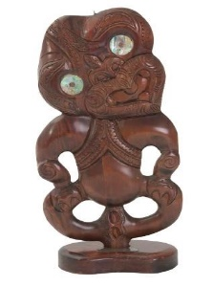
Te Puea Trophy  for the best Annual Report | Penrhyn Trophy  for the Runner Up – Annual Report | Gwen Ryan Trophy  for the best Rangatahi Report
Criteria | Criteria | Criteria
- The Annual Report belongs to a financial Senior Branch.  - Activities connect to the League Objects.  - Accomplishments of the Branch are outlined.  - Pictures, profiles, testimonials and anecdotes about the impact of your branch work are provided.  - Submit branch financial overview | - The Annual Report belongs to a financial Senior Branch.  - Activities connect to the League Objects.  - Accomplishments of the Branch are outlined.  - Pictures, profiles, testimonials and anecdotes about the impact of your branch work are provided.  - Submit branch financial overview | - The Annual Report belongs to a financial Rangatahi Branch.  - Activities connect to the League Objects.  - Accomplishments of the Branch are outlined.  - Pictures, profiles, testimonials and anecdotes about the impact of your branch work are provided.  - Submit branch financial overview

