
Te Roopu Wahine Maori Toko i te Ora
National Conference 2026 – Tamaki Makaurau
Due Drop Event Centre, 770 Great South Road, Wiri, Manukau, 2104, AUCKLAND
PUKAPUKA RESOURCES REGISTRATION

Rohe:
Peka:
Contact person:
Phone: |  | Email
Competition Entry: | ☐ Ikaroa (0-2 yrs) ☐ Ikaroa (3-5 yrs) ☐ Te Kahu o te Matauranga (6-9 yrs) (Please tick)
Please email your registration to competitions@mwwl.org.nz Registrations close Friday 28 August 2026.
- Ensure all tick boxes for branch entry is ticked above, or your item/s will not be accepted.
- It is the branch’s responsibility to bring competition items to National Conference.
- Competition items can be received on Wednesday 7 October at National Conference after powhiri.
- Competition items must be picked up by 4pm Saturday 10 October.
- Any further queries please contact the above email.

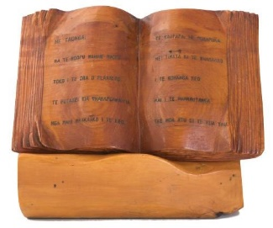 | 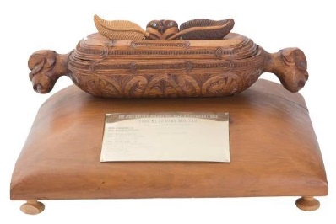 | 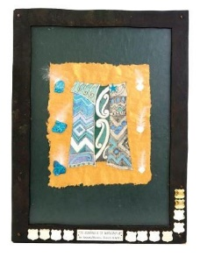
Ikaroa Trophy (0-2 yrs)  for the best Te Reo Resource Book for tamariki | Ikaroa Trophy (3-5 yrs)  for the best Te Reo Resource Book for tamariki | Te Kahu o te Matauranga (6-9 yrs)  for the best Te Reo Resource Book for tamariki
Criteria | Criteria | Criteria
- The pukapuka is written in Te Reo Maori for 0-2 year olds.  - The pukapuka has the title, author and illustrator details displayed on the front cover.  - The kaupapa must relate to  “Whakamaua te Aho Matua” weaving the Past, Present and Future.  - Must be 8 pages excluding the Title Page. | - The pukapuka is written in Te Reo Maori for 3-5 year olds.  - The pukapuka has the title, author and illustrator details displayed on the front cover.  - The kaupapa must relate to  “Whakamaua te Aho Matua” weaving the Past, Present and Future.  - Must be 10 pages excluding the Title Page. | - The pukapuka is written in Te Reo Maori.  - The pukapuka has the title, author and illustrator details displayed on the front cover.  - The kaupapa must relate to  “Whakamaua te Aho Matua” weaving the Past, Present and Future.  - Must be 8 pages excluding the Title Page.

