TE ROPU WAHINE MAORI TOKO I TE ORA
WAIARIKI ROHE – ROTORUA 2023
Arts & Crafts - Branch Report Registrations

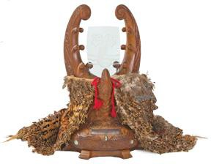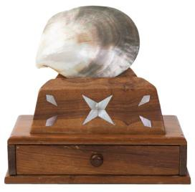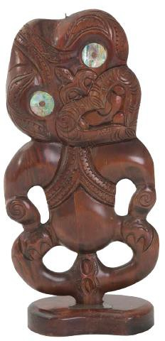
Te Puea Penrhyn Gwyn Ryan

Please  what entries you will be bringing to Nationals:
Te Puea Trophy (for Best Annual Report)
Gwyn Ryan Trophy (for Rangatahi Report)

The Penrhyn Trophy will be allocated to the runner up of the Te Puea Trophy.

- All entry forms must be received by or before Friday, 15th September 2023, 5.00 p.m.
- If the item is not ticked as per above, your item will not be accepted.
- It is the branches responsibility to bring all competition items to the National Hui.
- All competition items will be registered on Tuesday, 3rd October after the Powhiri – time to be advised.
- Competition items must be picked up – Friday, 6th October during morning tea.

Rohe
Peka
Contact Person
Cellphone: |  | Email:
Signed: |  | Date:

Please email form to: competitions@mwwl.org.nz

