
Te Roopu Wahine Maori Toko i te Ora
National Conference 2026 – Tamaki Makaurau
Due Drop Event Centre, 770 Great South Road, Wiri, Manukau, 2104, AUCKLAND
ANNUAL REPORT REGISTRATION

Rohe:
Peka:
Contact person:
Phone: |  | Email
Competition Entry: | ☐ Te Puea ☐ Penrhyn ☐ Gwen Ryan (Please tick)
Please email your registration to competitions@mwwl.org.nz Registrations close Friday 28 August 2026.
- Ensure all tick boxes for branch entry is ticked above, or your item/s will not be accepted.
- Annual reports to be couriered to National Office 24 Burnell Ave, Thorndon Wellington, 6011
by Friday 11 September 2026
- Annual Reports must be picked up at conference 4pm Saturday 10 October 2026.
- All queries to be forwarded to the above email.

 | 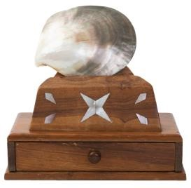 | 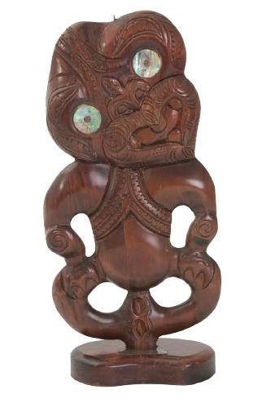
Te Puea Trophy  for the best Annual Report | Penrhyn Trophy  for the Runner Up – Annual Report | Gwen Ryan Trophy  for the best Rangatahi Report
Criteria | Criteria | Criteria
- The Annual Report belongs to a financial Senior Branch.  - Activities connect to the League Objects.  - Accomplishments of the Branch are outlined.  - Pictures, profiles, testimonials and anecdotes about the impact of your branch work are provided.  - Submit branch financial overview for 2025/2026 period. | - The Annual Report belongs to a financial Senior Branch.  - Activities connect to the League Objects.  - Accomplishments of the Branch are outlined.  - Pictures, profiles, testimonials and anecdotes about the impact of your branch work are provided.  - Submit branch financial overview for 2025/2026 period. | - The Annual Report belongs to a financial Rangatahi Branch.  - Activities connect to the League Objects.  - Accomplishments of the Branch are outlined.  - Pictures, profiles, testimonials and anecdotes about the impact of your branch work are provided.  - Submit branch financial overview for 2025/2026 period.

